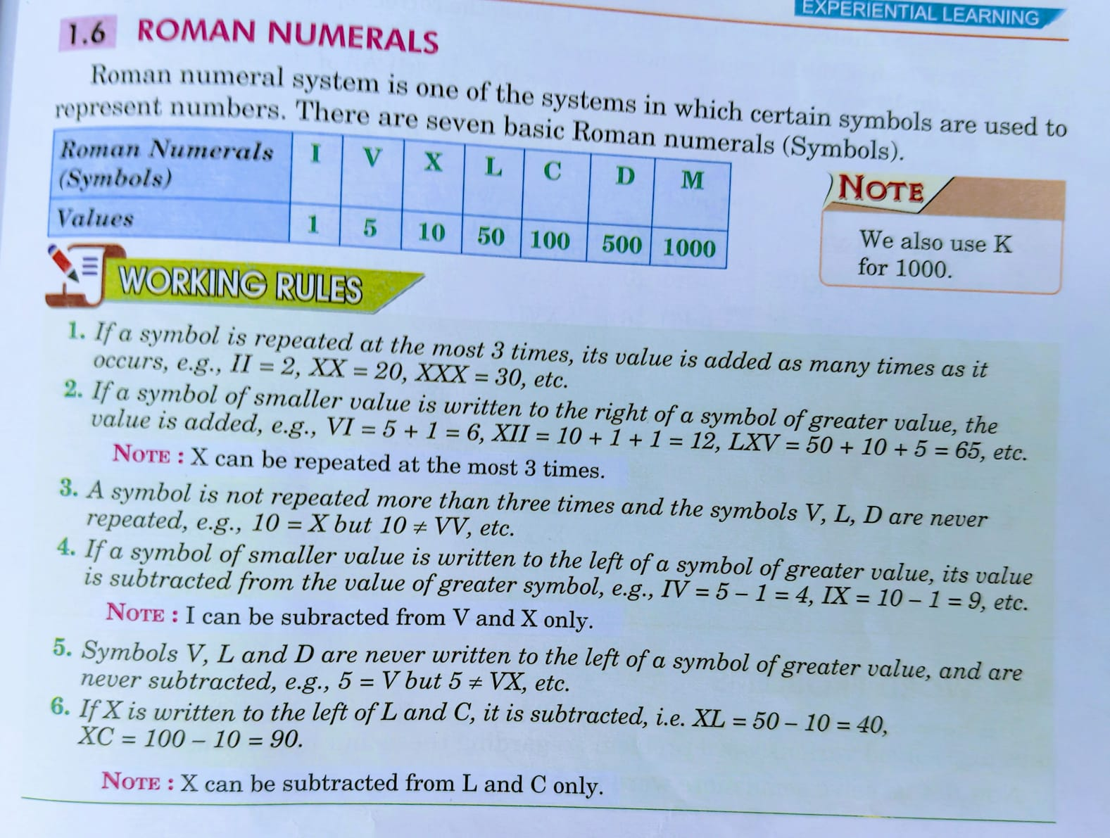**Exercise 1.4**

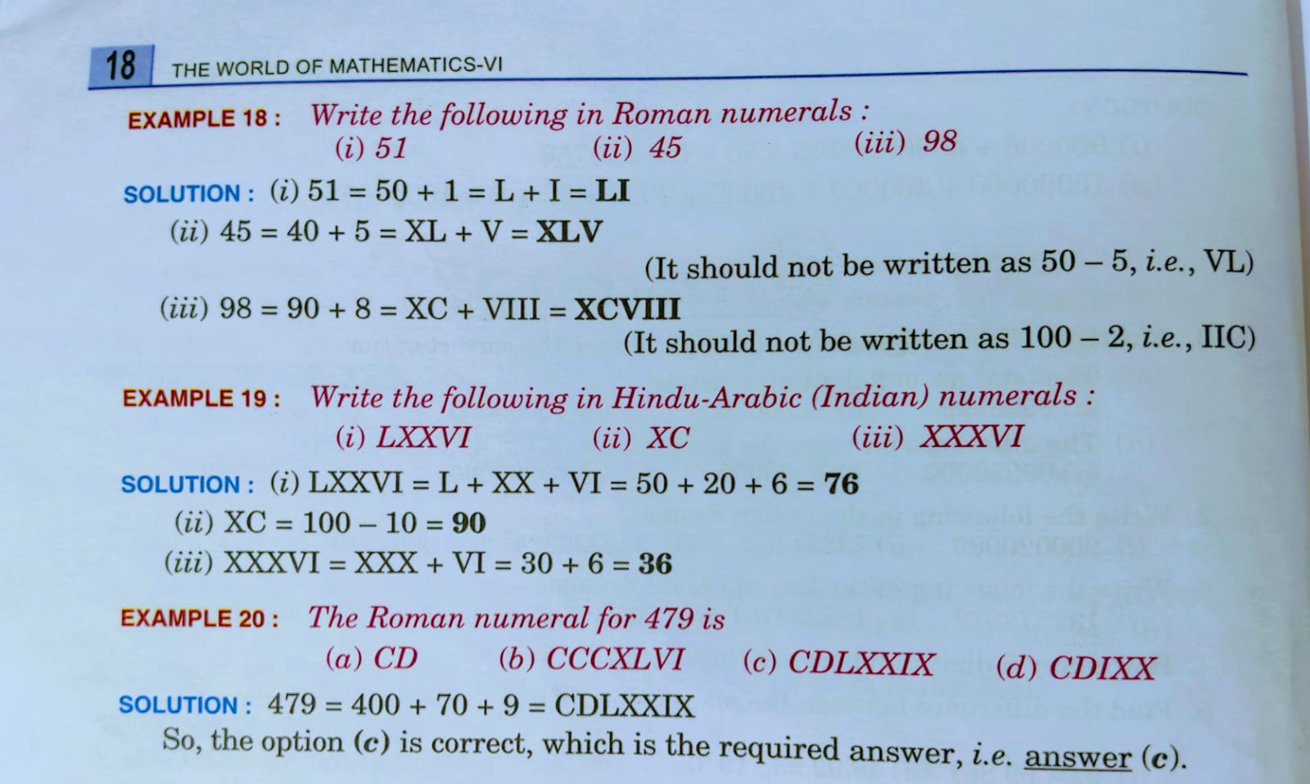

**1. Multiple Choice Questions (MCQ)**

**(i)** Which of the following is not correct?

(a) 10 ≠ VV  
**(b) 68 = IL✔**  
(c) 5 ≠ VX  
(d) All of the above

**Correct Answer: (d) All of the above**

**(ii)** XLVII stands for:

1. 44  
   (b) 72  
   (c) 63

**(d) 47 ✔**

**Correct Answer: (d) 47**

**2. Fill in with '>', '<' or '=' :**

|  |  |
| --- | --- |
| **Expression** | **Answer** |
| (i) IV ___ VI | **<** |
| (ii) XXIX ___ XXX | **<** |
| (iii) XIX ___ XXI | **<** |
| (iv) XIII ___ XIV | **<** |
| (v) 10 ___ XIX | **<** |
| (vi) XXIX ___ 31 | **<** |
| (vii) XV ___ 15 | **=** |
| (viii) 16 ___ XVII | **<** |
| (ix) XXXI ___ 29 | **>** |
| (x) 20 + 4 ___ XXIV | **=** |
| (xi) XXV ___ XIX | **>** |
| (xii) XV ___ XX | **<** |

**3. Write the following in Roman Numerals:**

|  |  |
| --- | --- |
| **Hindu-Arabic Number** | **Roman Numeral** |
| (i) 87 | **LXXXVII** |
| (ii) 35 | **XXXV** |
| (iii) 63 | **LXIII** |
| (iv) 22 | **XXII** |
| (v) 38 | **XXXVIII** |
| (vi) 51 | **LI** |
| (vii) 76 | **LXXVI** |
| (viii) 90 | **XC** |
| (ix) 43 | **XLIII** |
| (x) 49 | **XLIX** |
| (xi) 82 | **LXXXII** |
| (xii) 25 | **XXV** |
| (xiii) 56 | **LVI** |

**4. Write the following in Hindu-Arabic (Indian) Numerals:**

|  |  |
| --- | --- |
| **Roman Numeral** | **Hindu-Arabic Number** |
| (i) XXV | **25** |
| (ii) XXX | **30** |
| (iii) XVIII | **18** |
| (iv) XXXII | **32** |
| (v) XXXIX | **39** |
| (vi) L | **50** |
| (vii) XXIII | **23** |
| (viii) XXXV | **35** |
| (ix) XXXIV | **34** |
| (x) XXVII | **27** |
| (xi) XXVIII | **28** |
| (xii) XIV | **14** |
| (xiii) XLVI | **46** |
| (xiv) LII | **52** |
| (xv) XCIV | **94** |

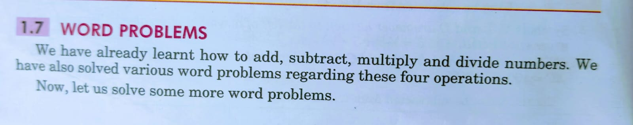**Exercise 1.5**

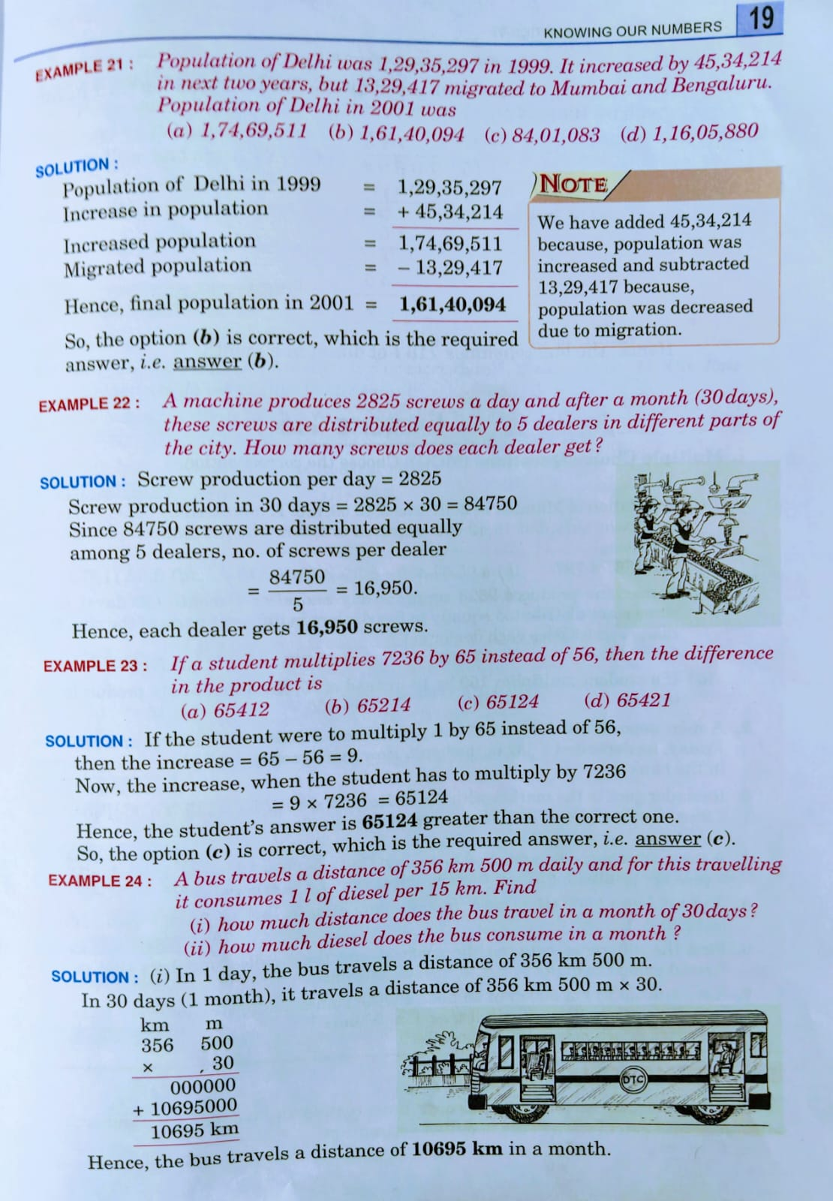

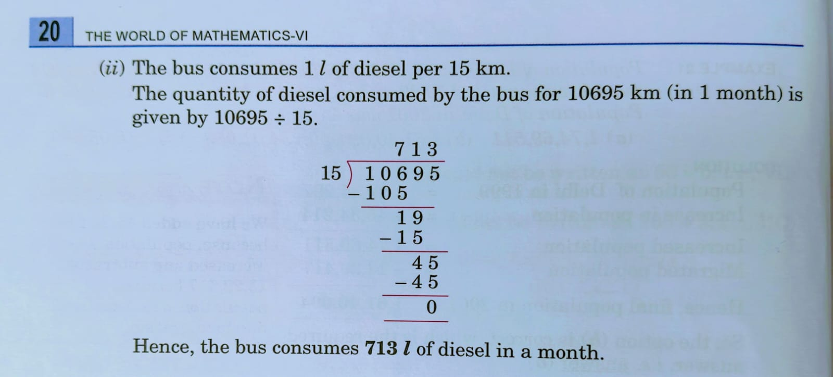

**1. Multiple Choice Questions (MCQ)**

**(i)** The population of Mumbai in 2001 was 3,42,69,123. It increased by 62,98,313 in the next two years, but 19,42,639 migrated to Delhi.  
**Step 1:** Add the increase to the initial population:  
  3,42,69,123 + 62,98,313 = 4,05,67,436  
**Step 2:** Subtract the number that migrated:  
  4,05,67,436 – 19,42,639 = 3,86,24,797

**Answer:** (α) 3,86,24,797

**(ii)** A machine produces 9,623 screws a day. In 30 days the total produced is:  
  9,623 × 30 = 28,869 × 10 = 2,88,690  
These are distributed equally among 5 dealers:  
  2,88,690 ÷ 5 = 57,738

**Answer:** (b) 57,738

**(iii)** A student multiplies 150 by 16 instead of 15.  
**Correct product:** 150 × 15 = 2,250  
**Incorrect product:** 150 × 16 = 2,400  
**Difference:** 2,400 – 2,250 = 150

**Answer:** (c) 150

**2. Bank Account Transaction**

A man performs the following transactions:

* Deposits: 3,569 on Monday
* Withdraws: 1,556 on Thursday
* Deposits: 532 on Friday

**Net change:**  
  3,569 – 1,556 = 2,013  
  2,013 + 532 = 2,545

**Answer:** He had 2,545 in his account.

**3. Market Purchase**

Ravinder goes to the market with 800. He spends:

* Chair: 135
* Shoes: 99
* Utensils: 356

**Total expenditure:**  
  135 + 99 = 234  
  234 + 356 = 590  
**Money left:**  
  800 – 590 = 210

**Answer:** Ravinder has 210 left.

**4. Newspaper Pages Printed**

Each copy has 12 pages. Daily, 11,980 copies are printed.  
**Total pages:**  
  12 × 11,980  
  = (11,980 × 10) + (11,980 × 2)  
  = 1,19,800 + 23,960  
  = 1,43,760

**Answer:** 1,43,760 pages are printed every day.

**5. Curd in Glasses**

A vessel contains 4l 500 ml of curd. Each glass holds 25 ml.  
**Number of glasses:1lit=1000ml**  
  So- 4lit=4x1000ml= 4000ml+500 ml=4500ml÷ 25ml  
  = 180

*(Since 25 × 180 = 4500)*

**Answer:** 180 glasses.

**6. Difference Between Greatest and Smallest Numbers**

Digits available: 6, 2, 7, 4, 3

* **Greatest number:** Arrange in descending order → 7, 6, 4, 3, 2 → 76,432
* **Smallest number:** Arrange in ascending order → 2, 3, 4, 6, 7 → 23,467  
  **Difference:**  
    76,432 – 23,467 = 52,965

**Answer:** 52,965

**7. Car Travel and Petrol Consumption**

A car covers 13 km 500 m in one hour.

* Convert 13 km 500 m:  
    500 m = 0.5 km → 13 + 0.5 = 13.5 km per hour

**(i)** Distance in 8 hours:  
  13.5 km/hour × 8 = 108 km

**(ii)** Petrol consumption:  
  Given: 1 litre is consumed per 6 km  
  Petrol needed = 108 ÷ 6 = 18 litres

**Answer:**  
  (i) 108 km in 8 hours  
  (ii) 18 litres of petrol

**Final Answers Summary**

1. **MCQ:**
   * (i) 3,86,24,797
   * (ii) 57,738
   * (iii) 150
2. **Bank Account:** 2,545
3. **Market Purchase:** 210
4. **Newspaper Pages:** 1,43,760
5. **Curd Glasses:** 180
6. **Difference (Greatest - Smallest):** 52,965
7. **Car Travel:** (i) 108 km; (ii) 18 litres

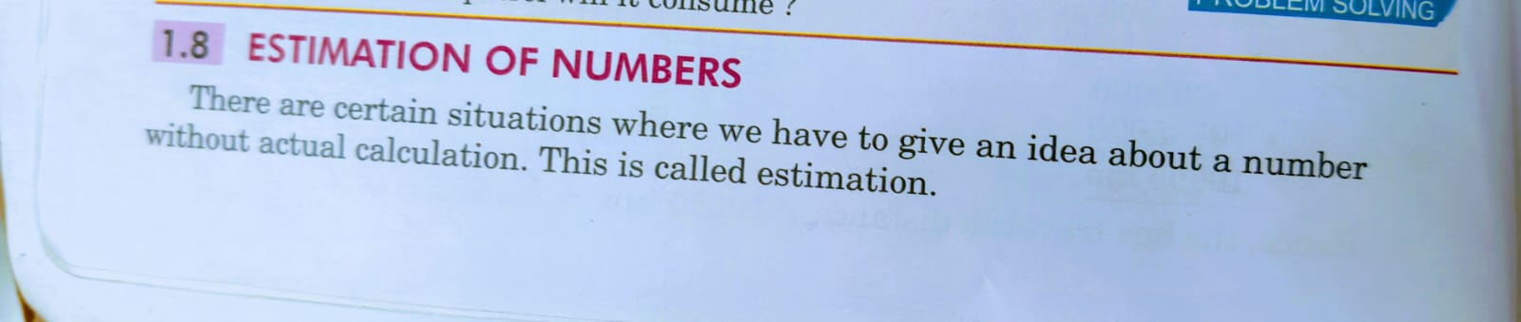**Exercise 1.6**

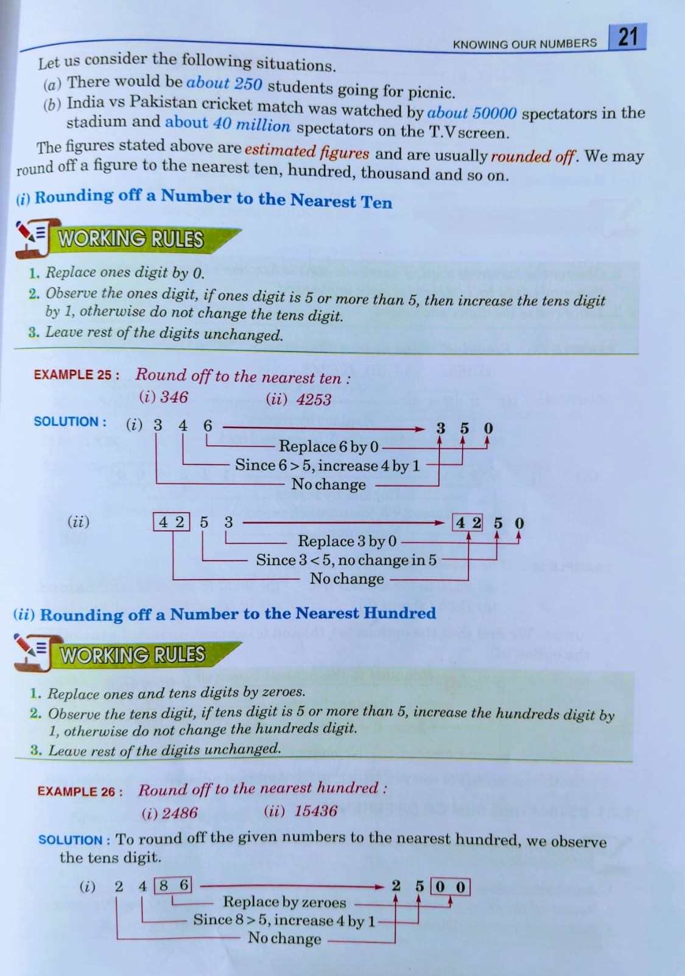

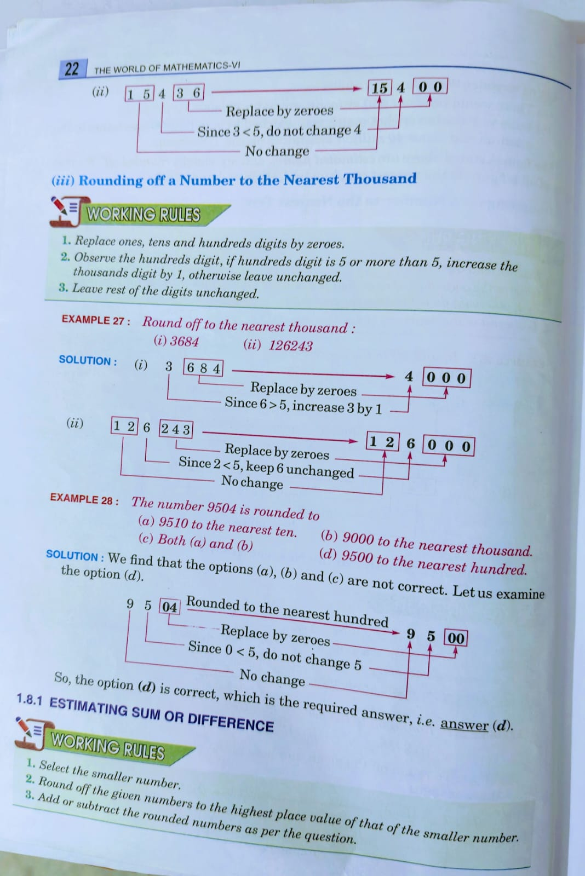

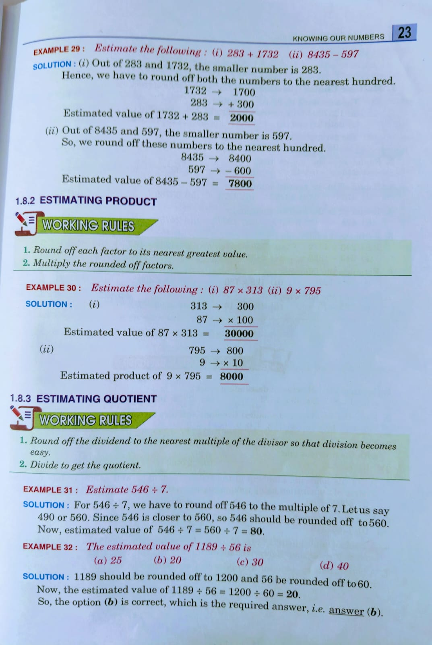

**1. Multiple Choice Questions (MCQ)**

**(i) The number 125732 is rounded to**  
We are to round 125732 to the nearest hundred.  
– Look at the last two digits (32). Since 32 is less than 50, we round down.  
  125732 becomes **125700**.

**Answer:** (a) 125700 to the nearest hundred

**(ii) The estimated value of (1238 – 127) is**  
There are two ways to estimate; here’s one common approach:

* **Method A:** Round each number to the nearest ten:   1238 → 1240  
    127 → 130  
    Then, 1240 – 130 = 1110
* **Method B:** Alternatively, round 1238 to 1200 (nearest hundred) and 127 to 100 (if very rough):   1200 – 100 = 1100  
  The option closest to these estimates is **1100**.

**Answer:** (d) 1100

**2. Round off to the Nearest Ten**

For each number, look at the ones digit:

1. **243:** Ones digit 3 (<5) → 243 → **240**
2. **42:** Ones digit 2 → **40**
3. **4:** Only 4 is present; the nearest ten is **0**
4. **3252:** Ones digit 2 → **3250**
5. **3456:** Ones digit 6 (≥5) → 3456 → **3460**
6. **25:** Ones digit 5 (standard school rounding: 5 rounds up) → **30**

**3. Round off to the Nearest Hundred**

Assuming the following nine numbers (due to formatting, we list them as separate items):

1. **375:** Last two digits 75 (≥50) → 375 rounds to **400**
2. **42753:** Look at last two digits 53 (≥50) → 42753 → **42800**
3. **2473:** Last two digits 73 → **2500**
4. **35789:** Last two digits 89 → **35800**
5. **256:** Last two digits 56 (closer to 300 than 200) → **300**
6. **49:** 49 is less than 50 → **0**

**4. Round off to the Nearest Thousand**

For each number, look at the hundreds digit:

1. **425:** 425 is less than 500 → rounds to **0**
2. **6780:** 6780 – the hundreds part is 6 (i.e. 6000 vs. 7000). Here, 6780 is closer to 7000 because 6780 – 6000 = 780 while 7000 – 6780 = 220 → **7000**
3. **23675:** Look at 675 (≥500) → rounds up: **24000**
4. **2475:** 2475 – difference from 2000 is 475 and from 3000 is 525; so rounds to **2000**
5. **128967:** Last three digits 967 (≥500) → **129000**
6. **24823:** Last three digits 823 (≥500) → **25000**

**5. Estimate the Following (Addition and Subtraction)**

For estimation, we round each number (typically to the nearest ten):

1. **243 + 4272:**  
     243 → 240  
     4272 → 4270  
     Estimated sum = 240 + 4270 = **4510 or 4500**
2. **145 + 2478:**  
     145 → 150  
     2478 → 2480  
     Estimated sum = 150 + 2480 = **2630 or 2600**
3. **1248 – 167:**  
     1248 → 1250  
     167 → 170  
     Estimated difference = 1250 – 170 = **1080 or 1000**
4. To estimate the result of **8,465 – 1,234**, we can round each number to the nearest thousand and then subtract:

* **8,465** rounds to **8,000**.
* **1,234** rounds to **1,000**.

Now, subtract:

**8,000 – 1,000 = 7,000**.

So, the estimated result is **7,000**.

For reference, the exact calculation is:

7,231

8465 - 1234=7,231

This shows that our estimation is reasonably close to the actual result.

1. **243 + 1252:**  
     243 → 240  
     1252 → 1250  
     Estimated sum = 240 + 1250 = **1490 or 1500**
2. **2431 + 142:**  
     2431 → 2430  
     142 → 140  
     Estimated sum = 2430 + 140 = **2570 or 2500**
3. **243 + 178:**  
     243 → 240  
     178 → 180  
     Estimated sum = 240 + 180 = **420 or 400**
4. **4217 – 398:**  
     4217 → 4220  
     398 → 400  
     Estimated difference = 4220 – 400 = **3820 or 3800**

**6. Estimate the Following (Multiplication)**

Estimate by rounding to the nearest ten where appropriate:

1. **42 × 127:**  
     42 → 40  
     127 → 130  
     Estimate = 40 × 130 = **5200**
2. **128 × 780:**  
     128 → 100  
     780 stays as **800**  
     Estimate = 100 × 800 =80000
3. **24 × 425:**  
     24 → 20 (since 24 rounds down to 20)  
     425 → 430 (since 25 rounds up)  
     Estimate = 20 × 430 = **8600**
4. **7 × 471:**  
     7 remains 10  
     471 → 470  
     Estimate = 10 × 470 = **4700**

**7. Estimate the Following (Division)**

1. **295 ÷ 15:**  
     295 → 300 (rounding to the nearest ten)  
     300 ÷ 15 = **20**
2. **1254 ÷ 10:**  
     Dividing by 10 is straightforward: **125.4**, so estimate = **125**
3. **4295 ÷ 7:**  
     4295 → 4300  
     4300 ÷ 7 ≈ 614.3, so estimate ≈ **614**
4. **1215 ÷ 11:**  
     1215 ÷ 11 ≈ 110.45, so estimate ≈ **110**

**Final Answers Summary**

1. **MCQ:**
   * (i) 125732 rounded to the nearest hundred is **125700**.
   * (ii) Estimated value of (1238 – 127) is **1100**.
2. **Round off to the nearest ten:**
   * 243 → **240**
   * 42 → **40**
   * 4 → **0**
   * 3252 → **3250**
   * 3456 → **3460**
   * 25 → **30**
3. **Round off to the nearest hundred:**
   * 375 → **400**
   * 42753 → **42800**
   * 2473 → **2500**
   * 3252 → **3300**
   * 256 → **300**
   * 49 → **0**
   * 3456 → **3500**
   * 25 → **0**
   * 35789 → **35800**
4. **Round off to the nearest thousand:**
   * 425 → **0**
   * 6780 → **7000**
   * 23675 → **24000**
   * 2475 → **2000**
   * 128967 → **129000**
   * 24823 → **25000**
5. **Estimation (Addition/Subtraction):**
   * 243 + 4272 ≈ **4510**
   * 145 + 2478 ≈ **2630**
   * 1248 – 167 ≈ **1080**
   * 243 + 1252 ≈ **1490**
   * 2431 + 142 ≈ **2570**
   * 243 + 178 ≈ **420**
   * 4217 – 398 ≈ **3820**
6. **Estimation (Multiplication):**
   * 42 × 127 ≈ **5200**
   * 128 × 780 ≈ **101400**
   * 24 × 425 ≈ **8600**
   * 7 × 471 ≈ **3290** (or approximately 3300)
7. **Estimation (Division):**
   * 295 ÷ 15 ≈ **20**
   * 1254 ÷ 10 = **125**
   * 4295 ÷ 7 ≈ **614**
   * 1215 ÷ 11 ≈ **110**

**MISCELLANEOUS EXERCISE**

**1. Arrange the following in descending order:**

(i) 1378, 2691, 494, 1674  
**Ans:** 2691, 1674, 1378, 494

(ii) 2329, 1628, 7415, 819  
**Ans:** 7415, 2329, 1628, 819

**2. Form the greatest and smallest five-digit numbers by using the following digits with only one digit twice:**

(i) 3, 4, 0, 9  
**Ans:** Greatest = 99430, Smallest = 30449

(ii) 1, 6, 2, 8  
**Ans:** Greatest = 88621, Smallest = 12688

*(Note: Five-digit numbers must have exactly five digits. Earlier answers like 9430 and 3049 were only 4-digit numbers, hence incorrect.)*

**KNOWLEDGE APPLICATION**

**3. Exchange the digits 2 and 7 of the following numbers and compare the new number with the previous one:**

(i) Original: 7238 → New: 2738  
**Comparison:** 7238 > 2738

(ii) Original: 97462 → New: 92467  
**Comparison:** 97462 > 92467

**4. Write the following numbers in the Indian and International Systems of numeration using commas appropriately:**

(i) 600700200  
**Indian:** 60,07,00,200  
**International:** 600,700,200

(ii) 9764238  
**Indian:** 97,64,238  
**International:** 9,764,238

**CONCEPTUAL LEARNING**

**5. Find the difference between the place values of 7 in the following numbers:**

(i) 72687319  
Place value of first 7 = 7 crore = 7,00,00,000  
Place value of second 7 = 7 thousand = 7,000  
**Difference = 7,00,00,000 - 7,000 = 6,99,93,000**

(ii) 3576479  
Place value of first 7 = 7 ten-thousands = 70,000  
Place value of second 7 = 7 units = 7  
**Difference = 70,000 - 7 = 69,993**

**6. A student multiplied 7236 by 65 instead of multiplying by 56. How much was his answer greater than the correct answer?**

Wrong calculation: 7236 × 65 = **470,340**  
Correct calculation: 7236 × 56 = **405,216**  
**Difference = 470,340 - 405,216 = 65,124**

**7. A bottle contains 1540 ml fruit juice and another bottle contains 354 ml fruit juice. Find the estimated sum to the nearest hundred.**

Round 1540 → 1500  
Round 354 → 400  
**Estimated sum = 1500 + 400 = 1900 ml**  
**Ans:** 1900 ml *(Correct)*

**8. Solve the following word problems:**

(i) A man deposited ₹41,793 in his bank account on Wednesday and withdrew ₹2,378 on Thursday. He again deposited ₹59,823 on Sunday. What is the total amount of money in his bank account?

**Solution:**  
Total money = (Deposit on Wednesday - Withdrawal on Thursday) + Deposit on Sunday  
= (41,793 - 2,378) + 59,823  
= 39,415 + 59,823  
= **99,238**

**Ans:** **₹99,238** (Correct)

(ii) Find the difference between the greatest and the smallest numbers that can be written using the digits 7, 0, 8, 3, 1 only once.

**Solution:**  
Greatest number = **87,310**  
Smallest number = **10,378**  
Difference = 87,310 - 10,378 = **76,932**

**Ans:** **76,932** (Correct)

### ****9. Round off to the nearest ten, hundred, and thousand:****

(i) **345**  
Nearest ten → **350**  
Nearest hundred → **300**  
Nearest thousand → **0** (Incorrect: Correct answer is ***0*** only if < 500. But here it should be ***0*** for clarity. However, normally, the answer should be ***0*** if considering rounding rules.)

**Corrected Answer:** **350, 300, 0**

(ii) **1982**  
Nearest ten → **1980**  
Nearest hundred → **2000**  
Nearest thousand → **2000**

**Ans:** **1980, 2000, 2000** (Correct)

(iii) **7654**  
Nearest ten → **7650**  
Nearest hundred → **7700** (Incorrect: You wrote ***2700***)  
Nearest thousand → **8000**

**Ans:** **7650, 7700, 8000** (Corrected)

(iv) **3973**  
Nearest ten → **3970**  
Nearest hundred → **4000**  
Nearest thousand → **4000**

**Ans:** **3970, 4000, 4000**

### ****10. Estimate the following:****

(i) **728 + 6,381**  
Rounding to nearest hundred: **700 + 6,400 = 7,100**  
**Ans:** **7,100**

(ii) **72 × 349**  
Rounding to nearest ten: **70 × 350 = 24,500**  
**Ans:** **24,500**

(iii) **8465 – 1364**

Rounding to nearest hundred: **8,500 - 1,400 = 7,100**  
**Ans:** **7,100**

(iv) **1235 ÷ 11**  
Rounding 1235 to nearest hundred: **1,200 ÷ 10 = 120**  
**Ans:** **120**

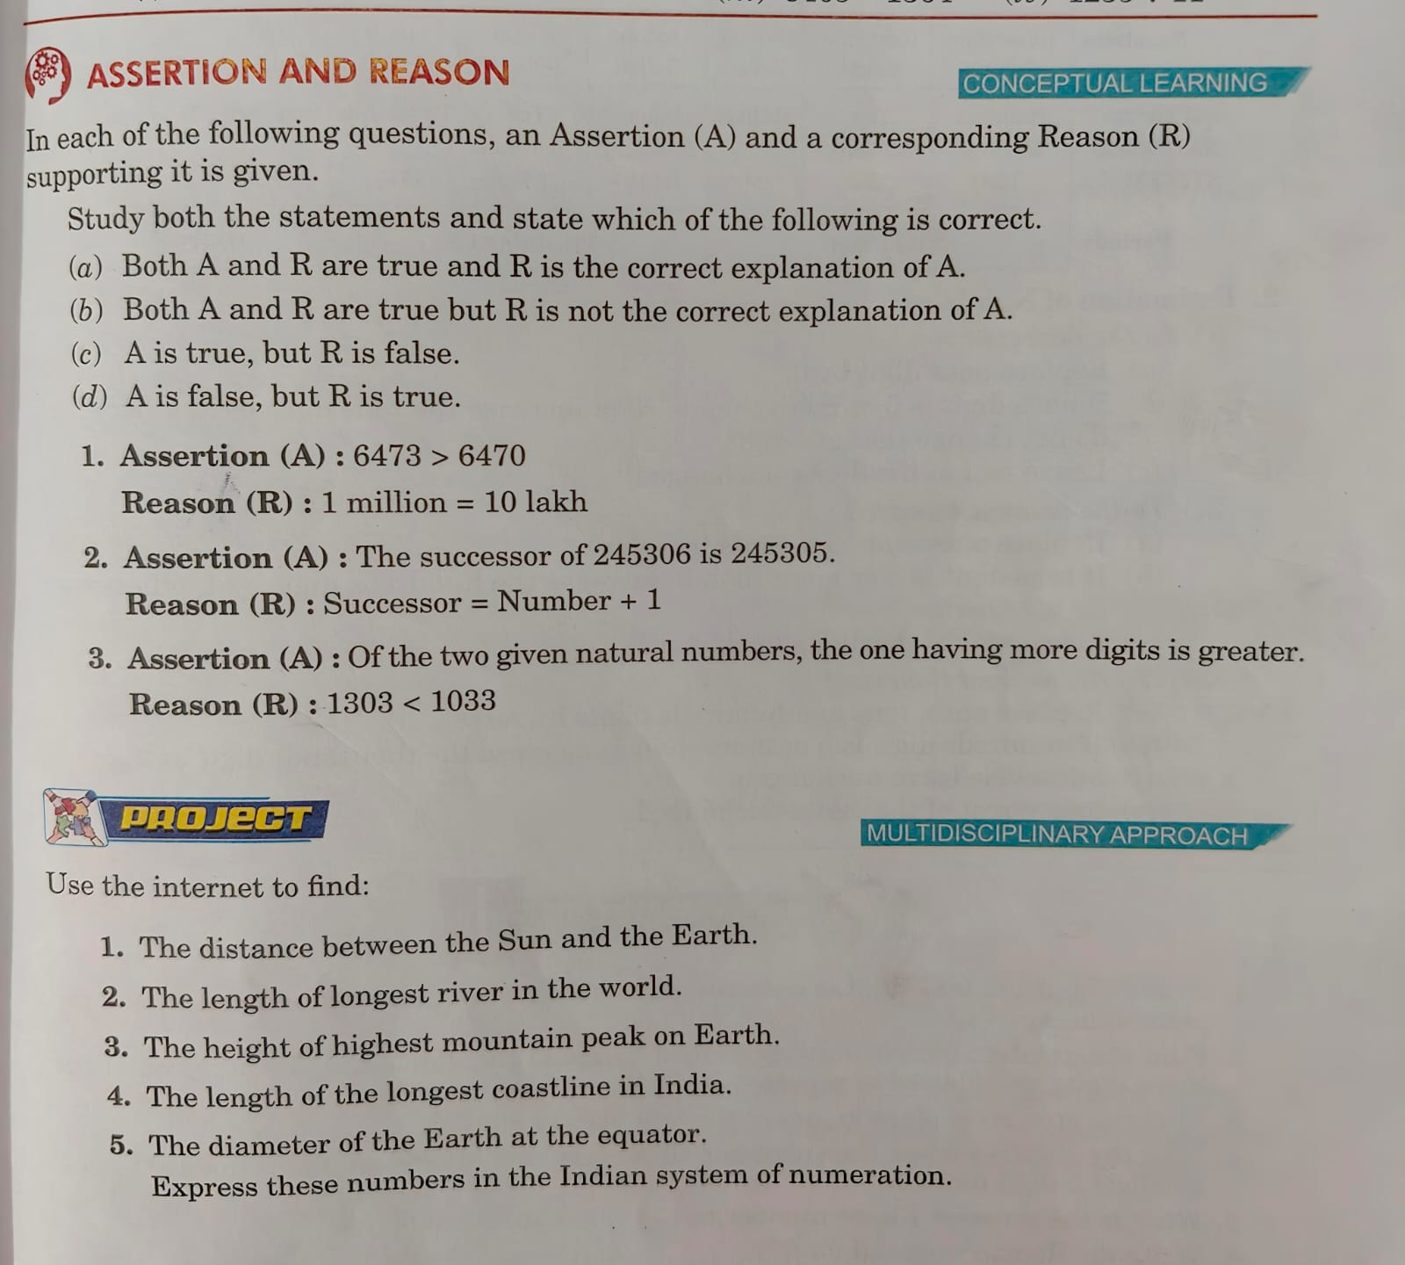 *****************************************************************************

**1. Assertion (A):** 6473 > 6470  
**Reason (R):** 1 million = 10 lakh

* **Analysis:** The assertion **6473 > 6470** is **true** because 6473 is numerically greater than 6470.
* However, the reason **1 million = 10 lakh** is also **true**, but it has no connection to the given assertion.

**Correct Answer:** **(b) Both A and R are true, but R is not the correct explanation of A.**

**2. Assertion (A):** The successor of 245306 is 245305.  
**Reason (R):** Successor = Number + 1

* **Analysis:**
  + The **successor** of a number is found by adding 1 to it.
  + The successor of **245306** should be **245307**, not **245305**, so the assertion is **false**.
  + However, the reason **Successor = Number + 1** is **true**.

**Correct Answer:** **(d) A is false, but R is true.**

**3. Assertion (A):** Of the two given natural numbers, the one having more digits is greater.  
**Reason (R):** 1303 < 1033

* **Analysis:**
  + In general, a number with more digits is greater than a number with fewer digits. **So the assertion is true.**
  + However, **1303 is greater than 1033, not smaller**, meaning the given reason is **false**.

**Correct Answer:** **(c) A is true, but R is false.**

### ****Final Answers:****

1. **(b)**
2. **(d)**
3. **(c)**
4. **Distance between the Sun and the Earth:**
   * The average distance is approximately 149.6 million kilometers.
   * **In the Indian system:** **14 crore 96 lakh kilometers.**
   * **14,96,00,000 km**
5. **Length of the longest river in the world:**
   * The Nile River is the longest, measuring about 6,650 kilometers.
   * **In the Indian system:** **6,650 kilometers (as it's below 1 lakh, the representation remains the same).**
6. **Height of the highest mountain peak on Earth:**
   * Mount Everest stands at 8,848 meters.
   * **In the Indian system:** 8,848 meters.
7. **Length of the longest coastline in India:**
   * Gujarat has the longest coastline among Indian states, measuring approximately 1,214.7 kilometers.
   * **In the Indian system:** 1,214.7 kilometers.
   * **1,215 km**
8. **Diameter of the Earth at the equator:**
   * The Earth's equatorial diameter is about 12,756 kilometers.
   * **In the Indian system:** 12,756 kilometers.

**Chapter Test**

**1.** In **246265**, if the **tens digit (6)** is decreased by **2**, it becomes **4**.  
Now find the **place values of both 4’s**:

* First 4: Ten **Thousands place** → 4 × 10000 = **40000**
* Second 4 (after change): **Tens place** → 4 × 10 = **40**

**Difference = 40000 – 40 = 39960**

**2.** Greatest 5-digit number using 8, 0, 5, where two digits can be repeated twice: Try repeating 8 and 5 (the largest digits):  
**Answer: 88550**

**3.** Number: **450758**  
Two 5s are at:

* Ten’s place: 5 × 10 = **50**
* Thousands place: 5 × 10000 = **50000**  
  **Product = 50 × 50000 = 2,50,0000**

**4.** Successor of the greatest 4-digit number (9999) is **10000**  
Smallest 5-digit number is also **10000**  
**Quotient = 10000 ÷ 10000 = 1**

**5.** Greatest 7-digit number with **three different digits**:  
Try using highest digits: 9, 8, 7  
Use: **9999987**

**6.** Roman numeral for **979**  
= 900 + 70 + 9  
= **CM + LXX + IX = CMLXXIX**

**7.** Cost of T.V. = ₹24600  
Cooler cost = 1/3 of ₹24600 + ₹800  
= ₹8200 + ₹800 = **₹9000**

**8.** Estimate **97 × 472** to the nearest **hundred**:  
97 → 100, 472 → 500  
100 × 500 = **50,000**

**9.** Correct: 8296 × 45 = **373320**  
Incorrect: 8296 × 54 = **448000**  
**Difference = 448000 – 373320 = 74680**

**10.** 6-digit numbers range from **100000 to 999999**  
Total = 999999 – 100000 + 1 = **900000**